Ika’s wellness spa

User Guide

Contents

Opening Ika’s Wellness 2

Client Receipt 3

Daily Sales Report 4

For Daily Sales Report 5

For Date Range Report 5

PDF Report for Daily and Date Range Reports 5

Excel Report for Daily and Date Range Reports 6

Therapist Sales Report 8

For Therapist Sales Daily Report 8

For Therapist Sales Date Range Report 8

PDF Report for Therapist Sales Report 9

Void Sale 11

To Void a Sale 11

Viewing Non-Voided Sales and Voided Sales 14

# Opening Ika’s Wellness

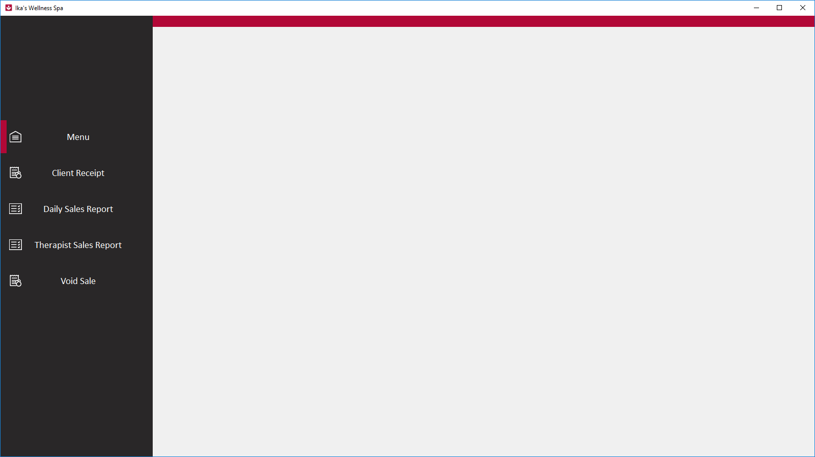

1. Open by Desktop shortcut



1. Open by Start Menu shortcut



1. When User Account Control pops-up just click Yes.

# Client Receipt

Click Client Receipt to enter sales for Ika’s Wellness Spa

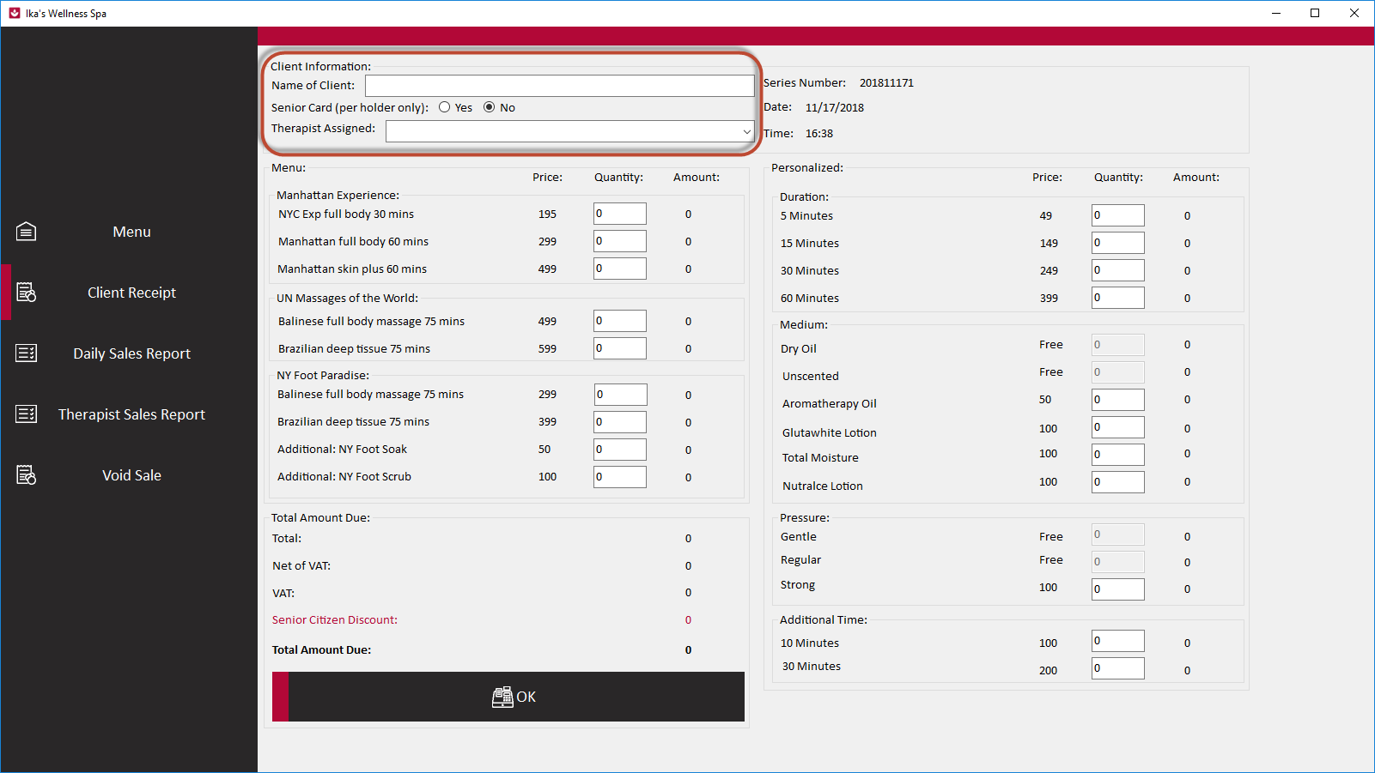

The Client Information must have values and at the Menu there should be at least one (1) sale before entering a sale.

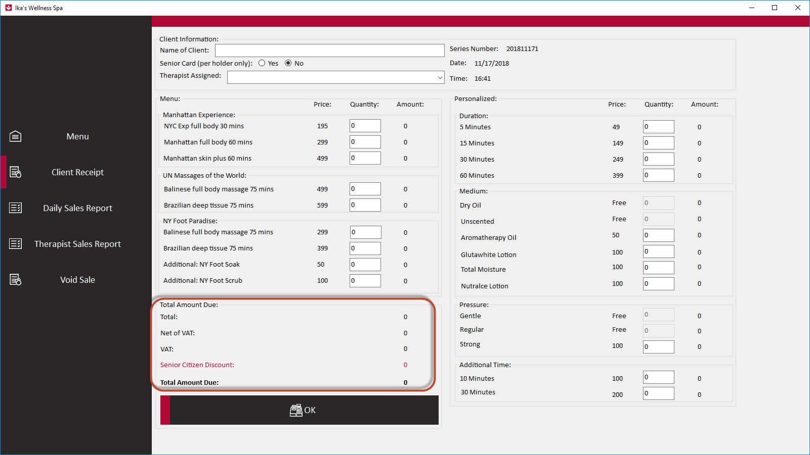

The application would automatically compute and apply senior citizen discount if selected.

When all the information and sales are entered correctly click the OK button to enter a sale.

A pop up would display for confirmation that the sale was successfully saved. You can click OK to continue.

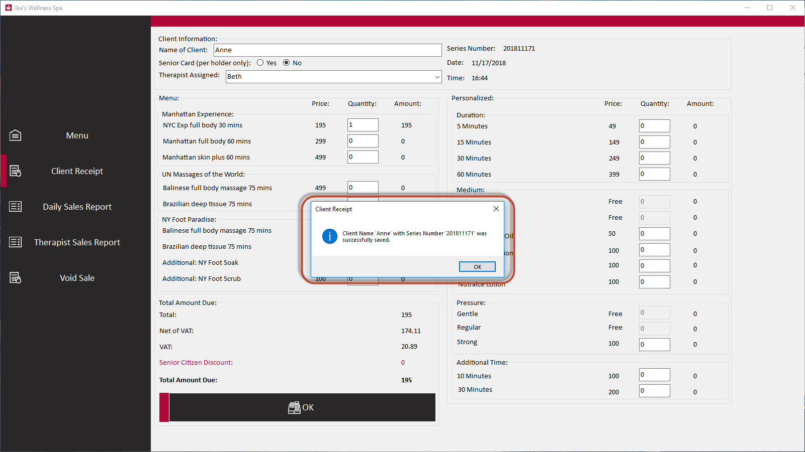

# Daily Sales Report

Click Daily Sales Report to generate Daily Sales report.

You can generate reports daily or date range.

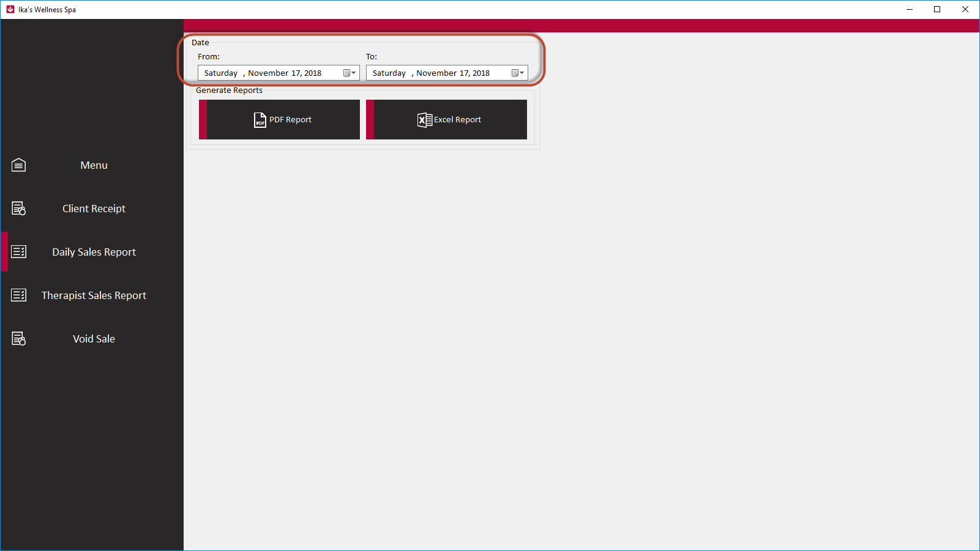

## For Daily Sales Report

The From and To Date should be the same in order to generate a daily report of the selected date.

You can choose between PDF Report and Excel Report.

## For Date Range Report

Enter the From date and To date in order to generate a Date Range report from the selected from and to dates.

You can choose between PDF Report and Excel Report.

## PDF Report for Daily and Date Range Reports

When PDF report is clicked, it would ask for the location where to save the generated PDF report. You can freely choose where to save the report or leave it on the default location.

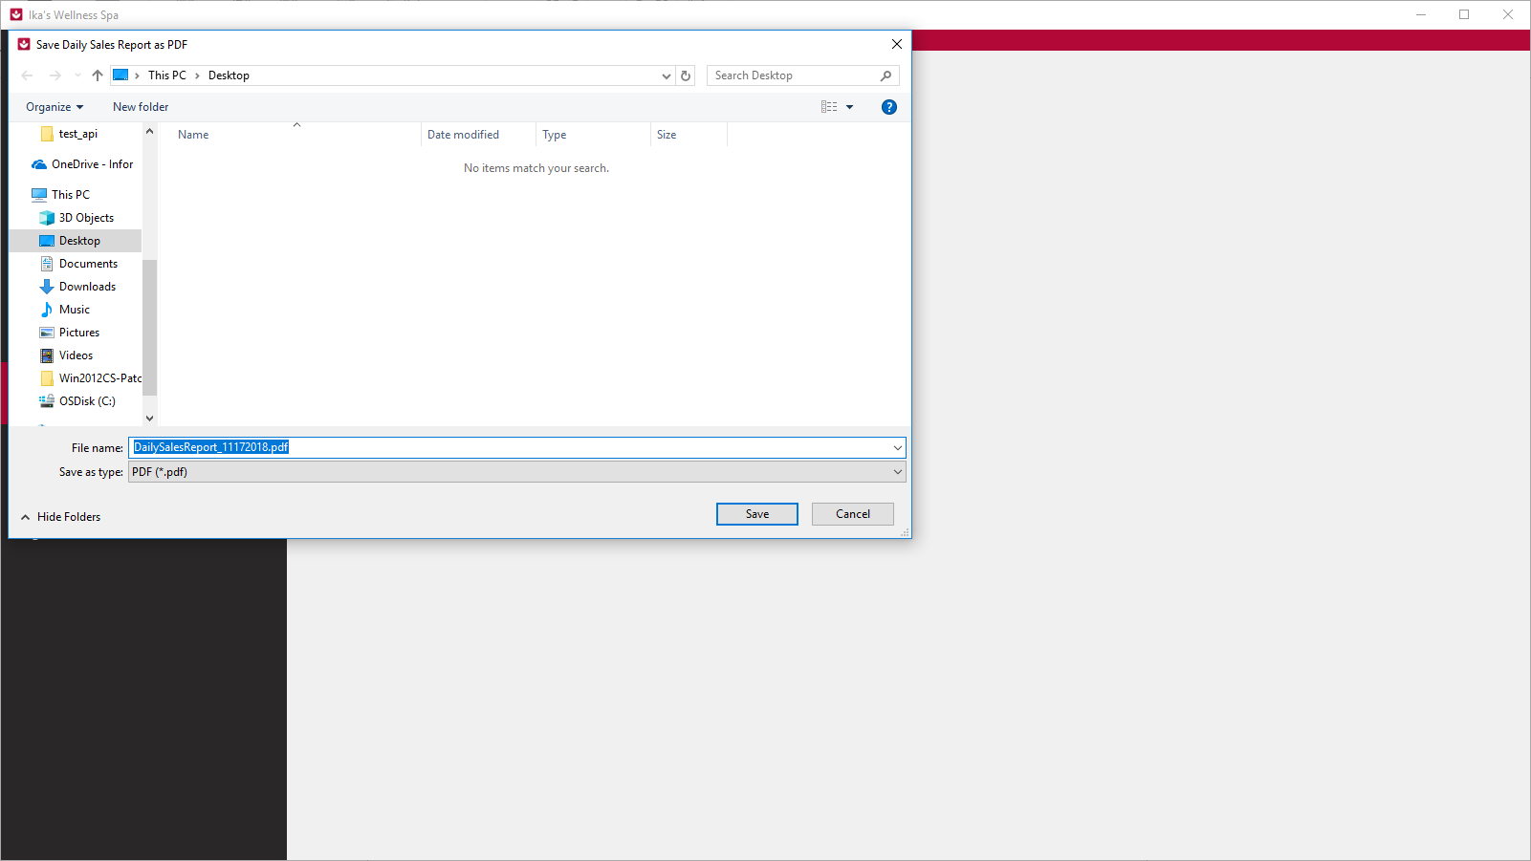

The PDF name report has the following format “DailySalesReport_<THE_FROM_DATE_VALUE>.pdf”.

Click Save to save the generated PDF Report of Daily Sales Report.

A pop up would display for confirmation that the PDF Report of Daily Sales Report was created successfully. You can click OK to continue.

**Note: You’ll need to wait for this pop up to display in order to continue.**

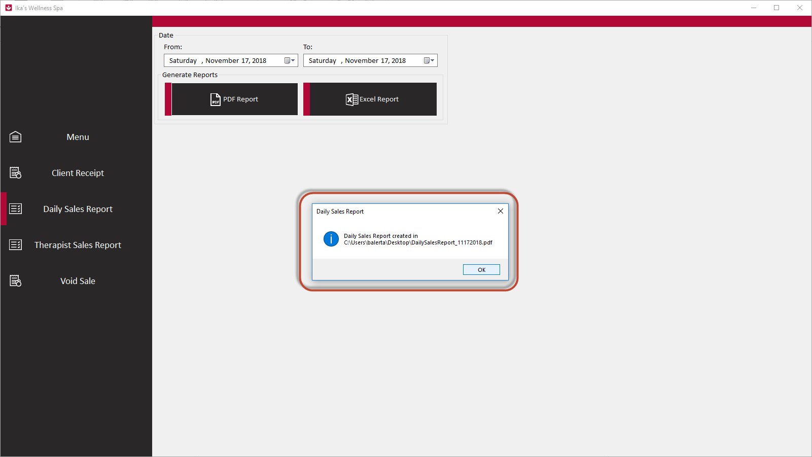

**Note: You’ll need a PDF reader or Acrobat Reader DC in order to view the file.**

## Excel Report for Daily and Date Range Reports

When Excel report is clicked, it would ask for the location where to save the generated Excel report. You can freely choose where to save the report or leave it on the default location.

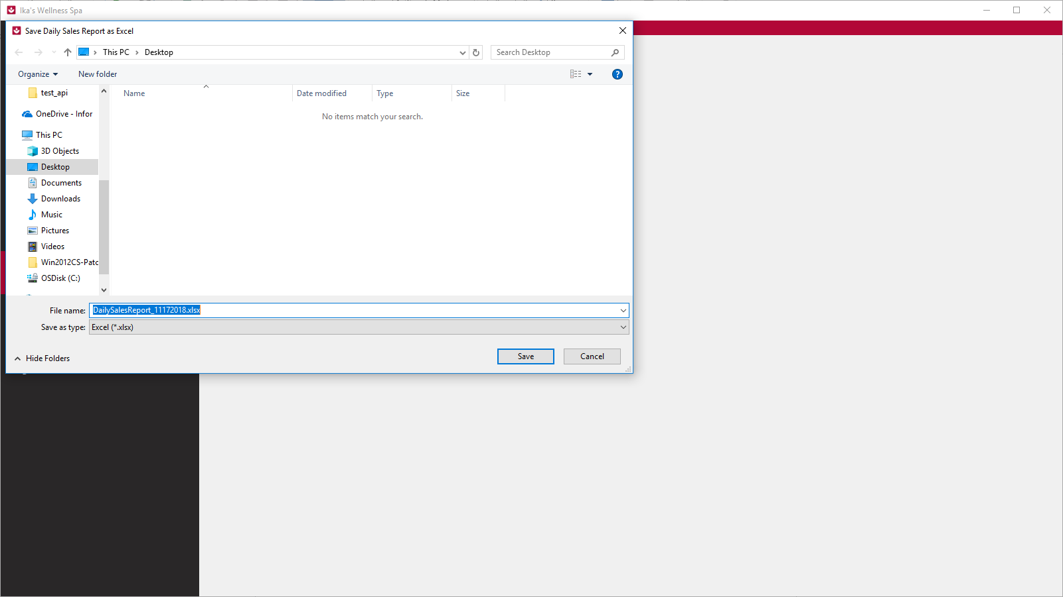

The Excel name report has the following format “DailySalesReport_<THE_FROM_DATE_VALUE>.xlsx”.

Click Save to save the generated Excel Report of Daily Sales Report.

A pop up would display for confirmation that the PDF Report of Daily Sales Report was created successfully. You can click OK to continue.

**Note: You’ll need to wait for this pop up to display in order to continue.**

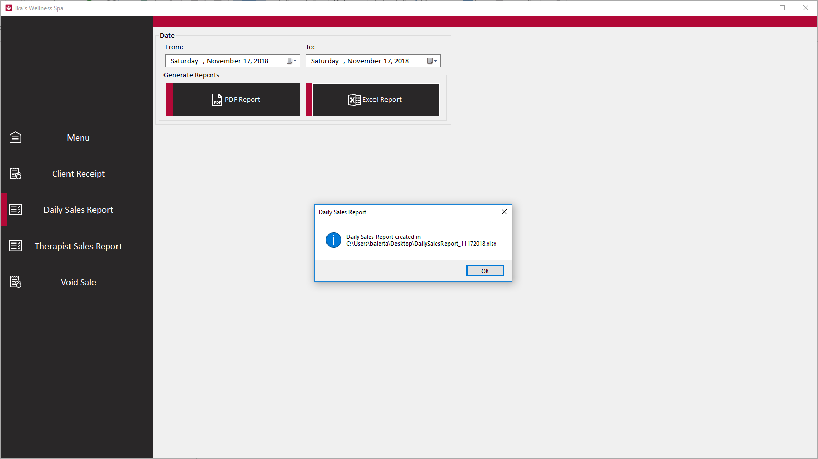

**Note: You’ll need a Microsoft Excel in order to view or edit the file.**

# Therapist Sales Report

Click Therapist Sales Report in order to generate a Therapist Sales Report by daily or date range.

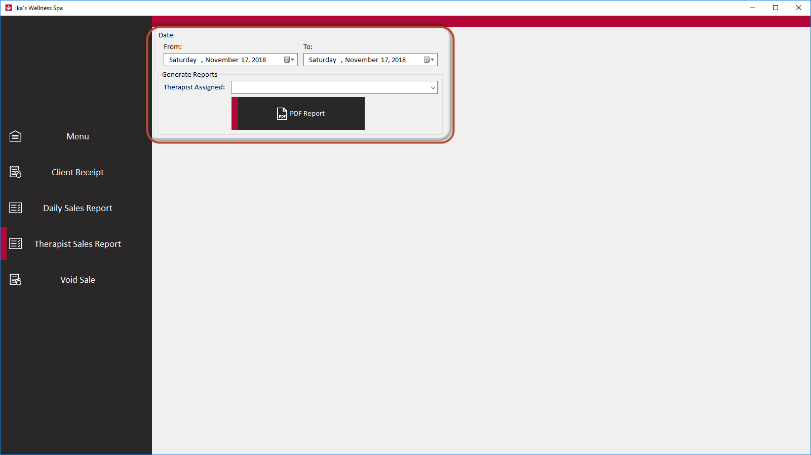

## For Therapist Sales Daily Report

The From and To Date should be the same, select a therapist in order to generate report for the selected Therapist and the date selected.

## For Therapist Sales Date Range Report

Enter the From date and To, select a therapist in order to generate report for the selected Therapist and the date range entered.

## PDF Report for Therapist Sales Report

When PDF report is clicked, it would ask for the location where to save the generated PDF report. You can freely choose where to save the report or leave it on the default location. 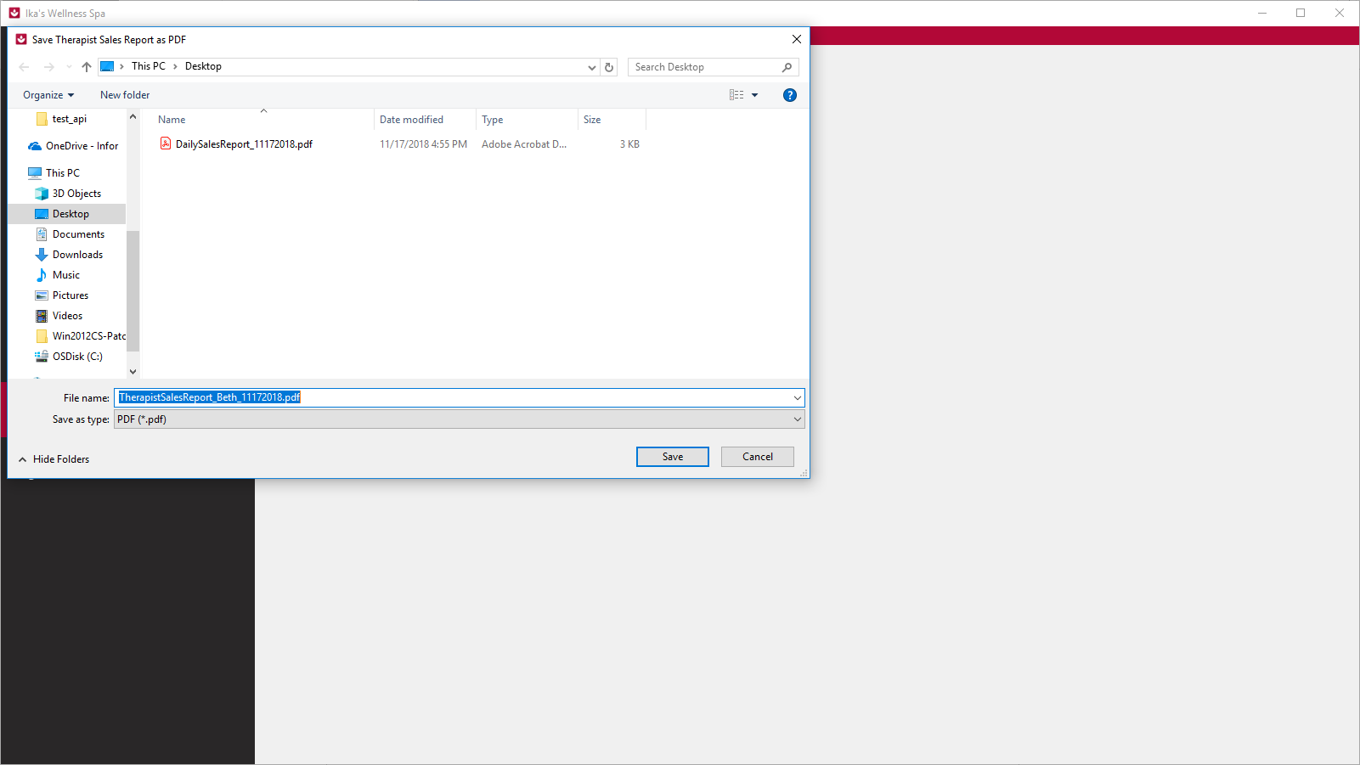

The PDF name report has the following format “TherapistSalesReport_<SELECTED_THERPIST>_<THE_FROM_DATE_VALUE>.pdf”.

Click Save to save the generated PDF Report of Therapist Sales Report.

A pop up would display for confirmation that the PDF Report of Therapist Sales Report was created successfully. You can click OK to continue.

**Note: You’ll need to wait for this pop up to display in order to continue.** 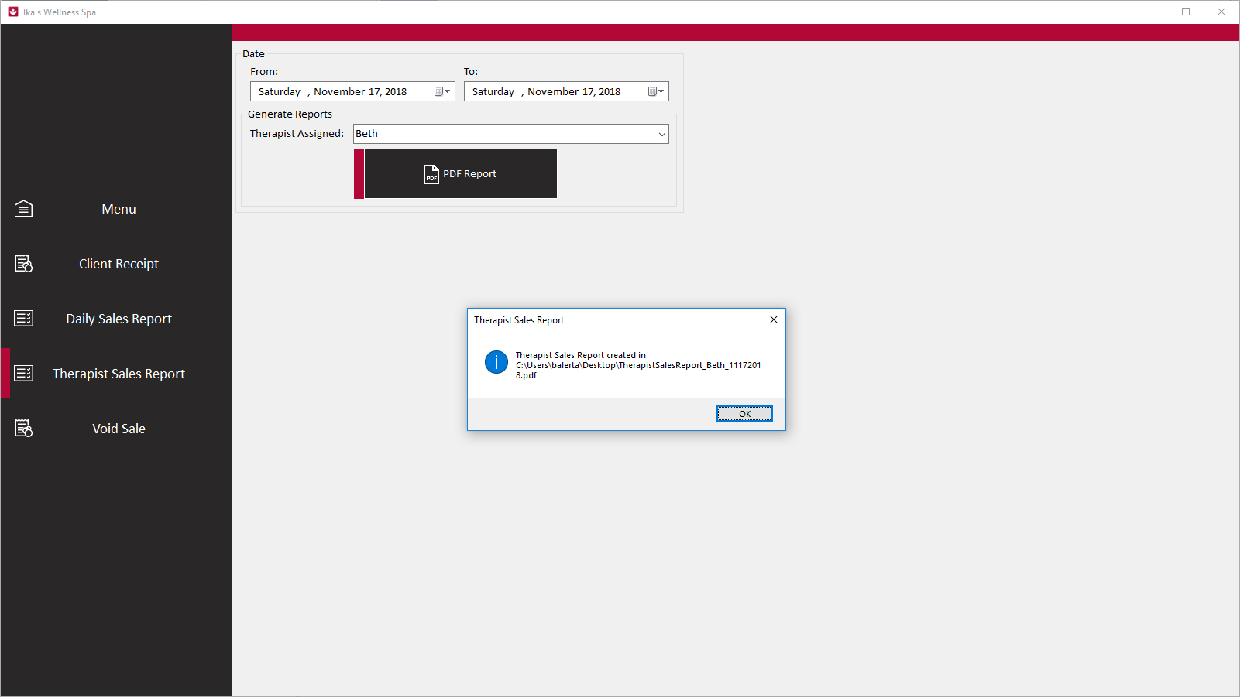

**Note: You’ll need a PDF reader or Acrobat Reader DC in order to view the file.**

# Void Sale

Click Void Sale to void an entered sale. Voiding a sale would not include it from the reports. 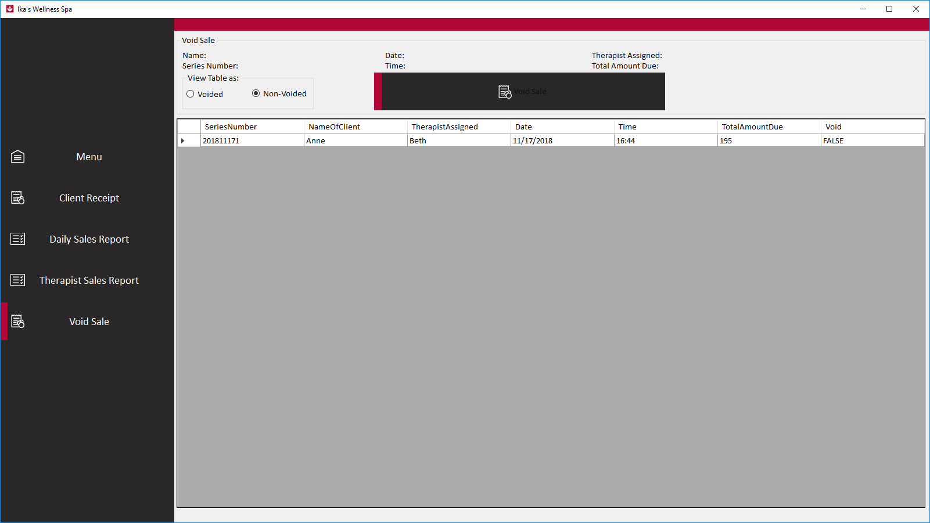

## To Void a Sale

Click the sale on the table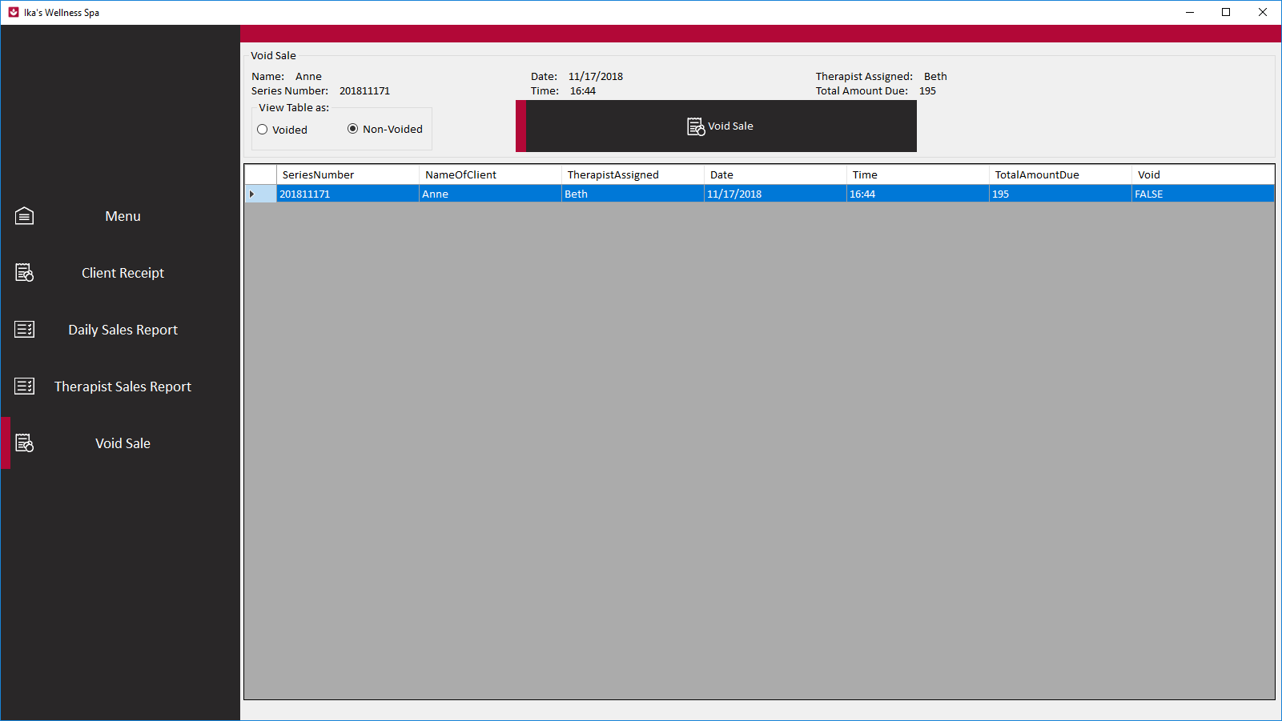

The Void Sale button would be enabled, and the information of the selected sale would display.

You now have the option to Void this sale, click the Void Sale button.



Enter the Admin Password for in order to Void this particular Sale.

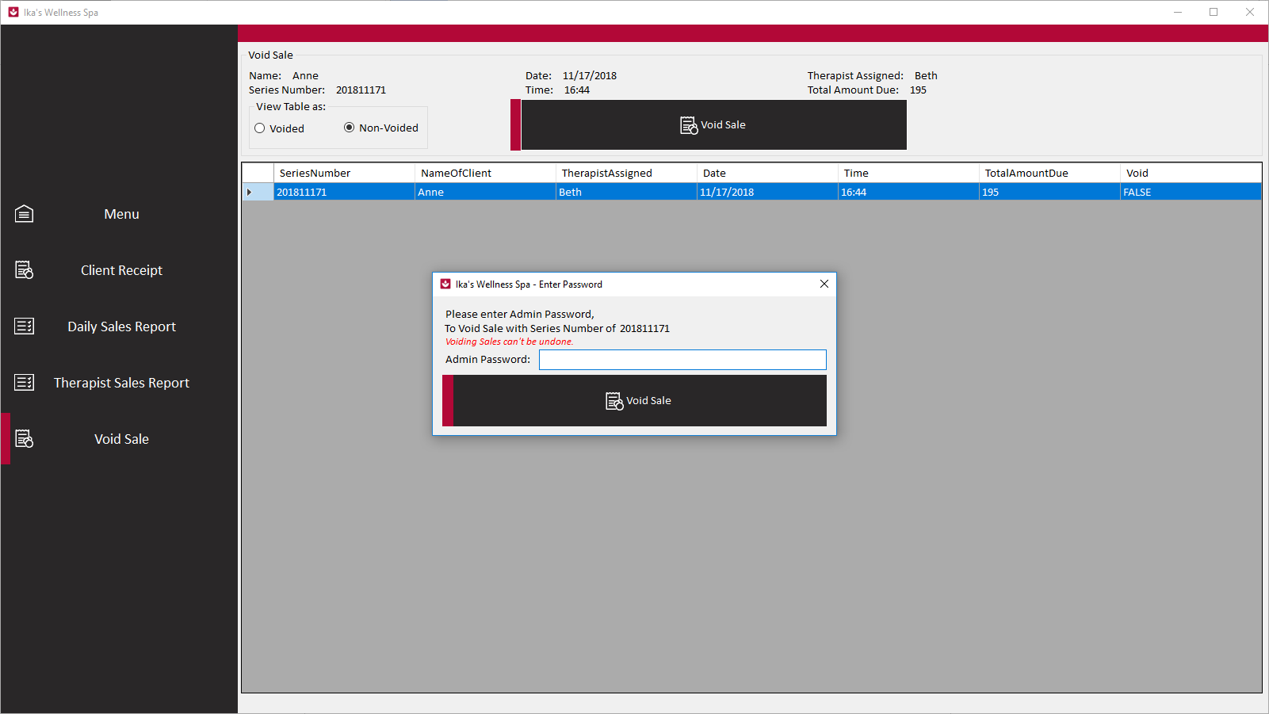

Once you entered the correct Admin Password, a pop up would display for confirmation that you have successfully voided the selected sale. 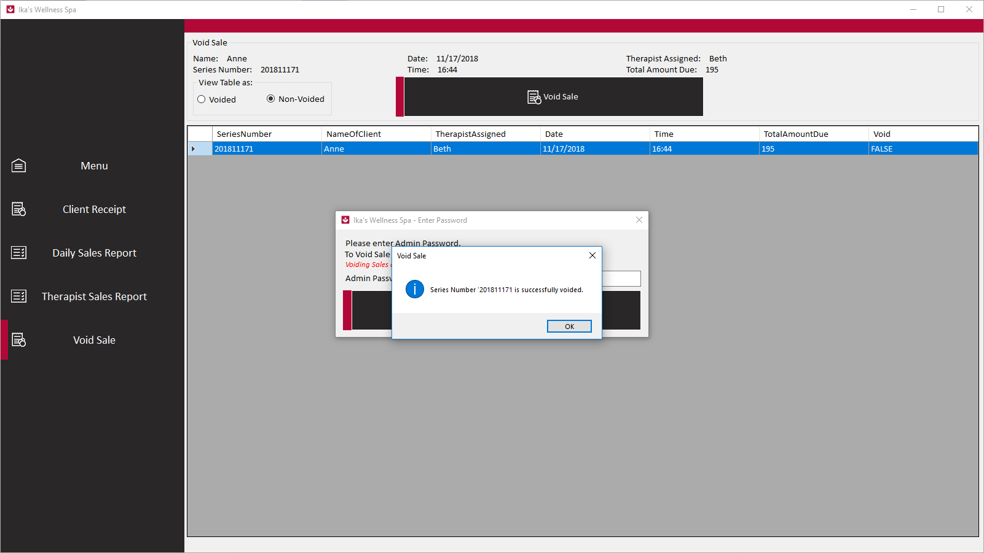

You can click OK to continue.

## Viewing Non-Voided Sales and Voided Sales

You can view the Non-Voided Sales and Voided Sales by click the Voided and Non-Voided under the “View Table as:”. 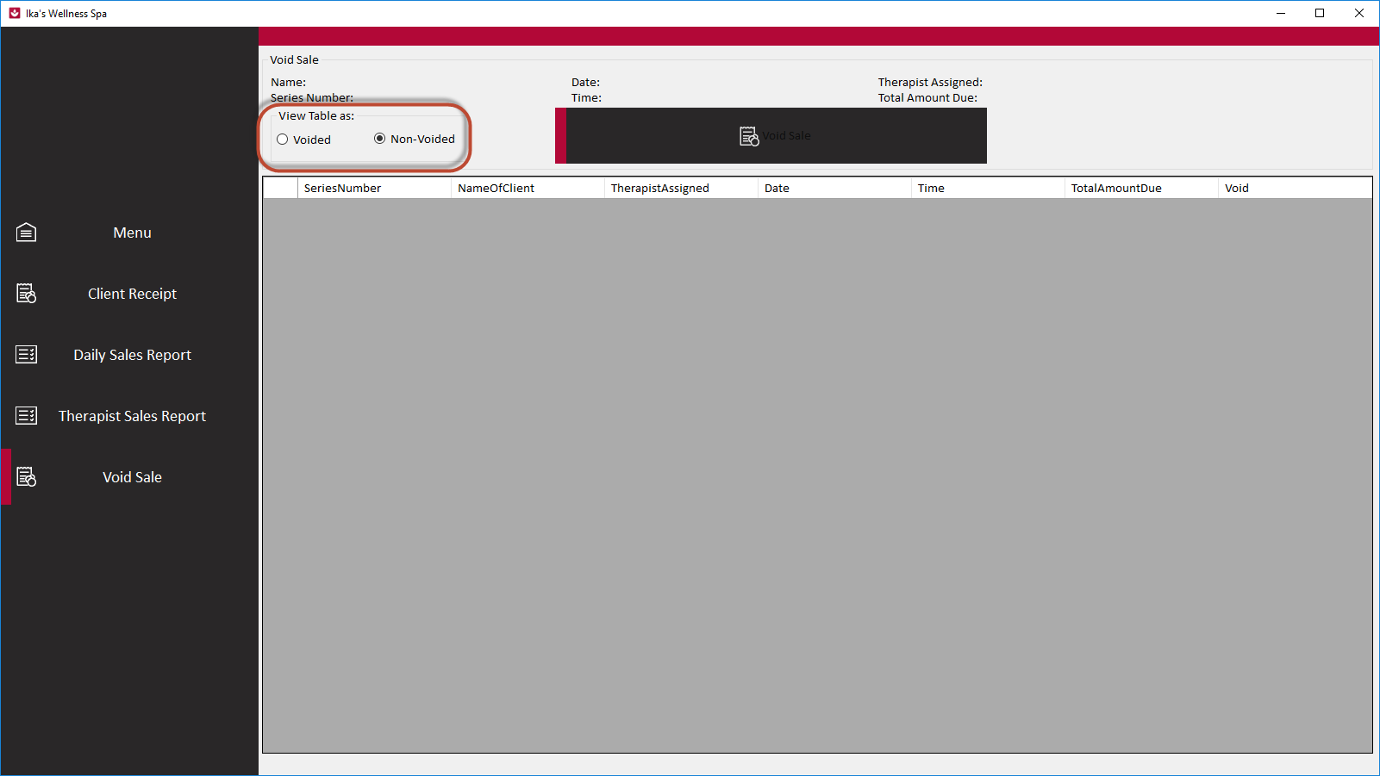

*Viewing Non-Voided*

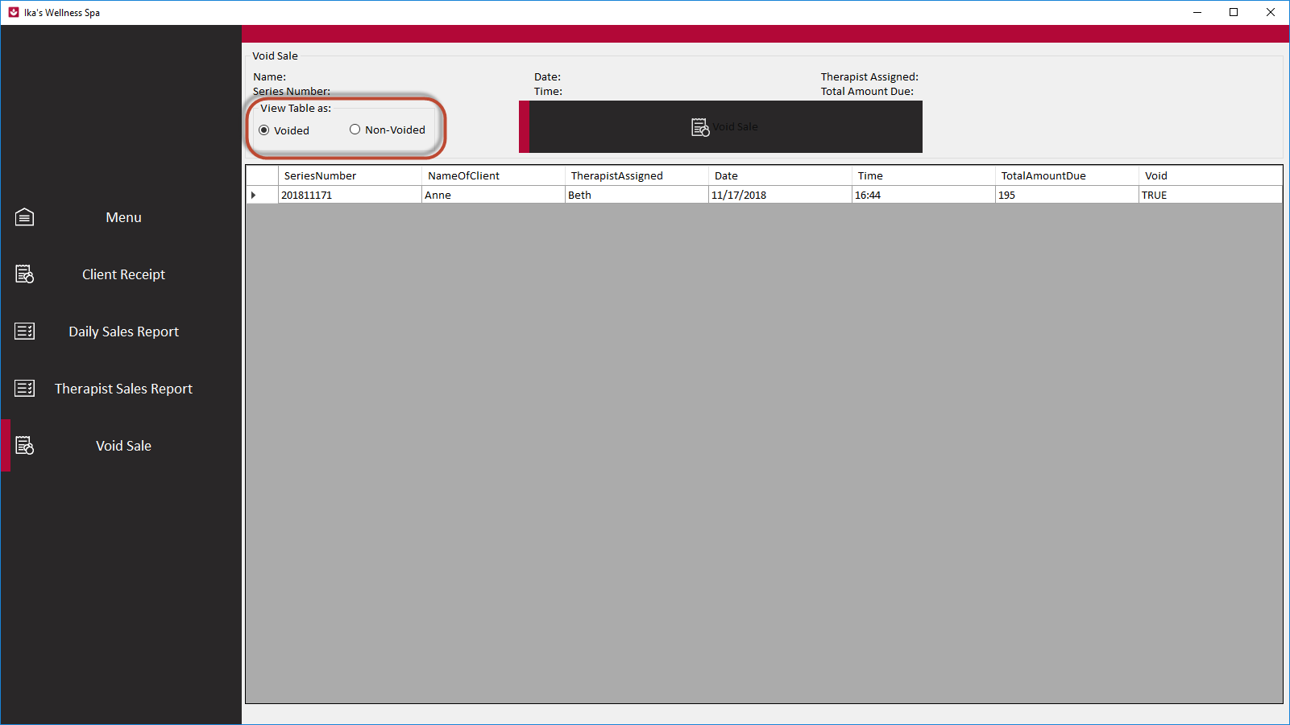

*Viewing Voided*